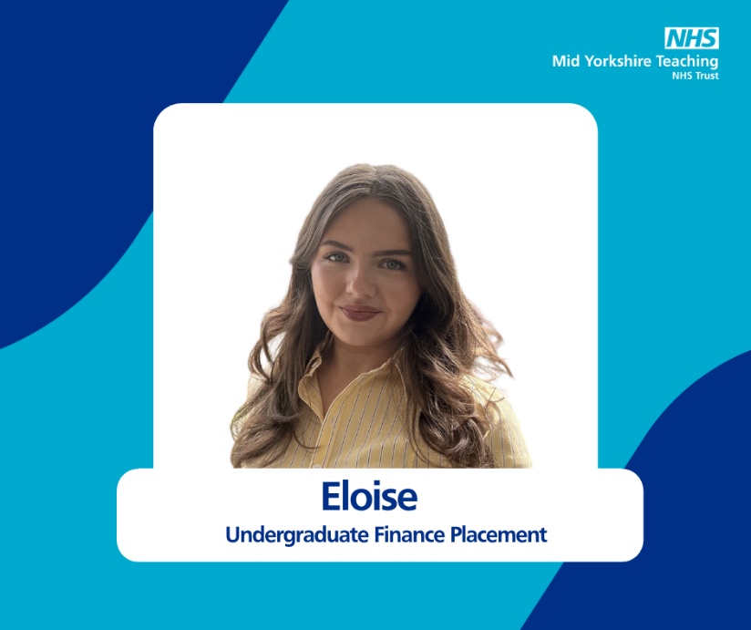
Eloise is approaching the end of her university placement with the Trust's Finance Department. We caught up with her to hear how it’s gone and the impact it has had on her future career aspirations.
How did you find out about the placement?
I found out about the placement through my university’s placement team, who would regularly send out emails with available opportunities. I also came across the placement when searching on various platforms such as Handshake and Bright Network, and it was one which instantly stood out to me.
Did you consider working for the NHS before you started the placement?
Before the placement, I hadn’t really considered working for the NHS. As an accounting and finance student, I’d previously only really focused on roles within the private sector. But when I came across this opportunity, I was instantly curious to see how one of the largest public sector services, and such an integral part of our society, operates behind the scenes.
Now, after a year here, I’m so glad that I took the chance.
What have you enjoyed the most about working in the Finance Department?
Working within the finance team has been great, everyone has been nothing but supportive and patient. It’s really helped to foster an environment where I’ve been able to develop my skills and learning significantly and felt easy to ask questions.
I’ve also loved how varied the experience has been. It’s been really interesting working in a healthcare setting and with clinical staff, it’s given me a unique perspective on how finance supports frontline healthcare services.
I’ve had the chance to work across different teams, take on new challenges, and shadow colleagues to see the wider impact of our work.
What kind of projects / tasks have you been involved in?
Throughout the year, I’ve mainly worked in the Families and Clinical Support Services team, but also helped out with some tasks in the Surgery and Corporate teams. My responsibilities have included analysing expenditure, updating KPI analysis, raising invoices, processing journals, and supporting budget holder meetings.
Recently, I helped present some budget holder training and became a Finance and Clinical Educator (FACE) and Value Maker with One NHS Finance. Another real highlight was shadowing our FCSS Head of Finance, which gave me a better understanding of how all our work behind the scenes is utilised to produce new processes and improve efficiency within the service.
What are your plans when the placement finishes?
In September I will be returning to the University of York to complete my final year, and then I’ll be looking to start a graduate role in finance.
The NHS is definitely somewhere I’d consider working again. This experience has not only helped me to develop key employability skills and readied me for a future career in finance, but also given me insight into how rewarding a finance career in the public sector can be.
The Trust's Finance Department has been offering placements for over 10 years. We currently offer two placements each academic year, which are advertised directly with universities.
We asked Steve Barron, Assistant Director of Finance what the benefits of the placements are.
There are many benefits for both the students and MYTT. The students gain valuable experience by learning about various aspects of working in finance within the NHS, allowing them to put much of their academic learning into practice before entering their final year of study.
Meanwhile, MYTT benefits from having a dedicated employee for a year, someone who is eager to learn and contribute. It also helps to secure a future recruitment pipeline, as we have numerous examples of these students returning to the organisation and securing permanent roles after completing their final year at university.

