Manchester Metropolitan University (MMU) Summer Project – Case Study

Organisation name: Tameside & Glossop NHS ICFT (TGH)
Location/region: Greater Manchester
Type of Organisation: Acute Trust
Department: Finance

Project Title: MMU Summer Finance Project
Dates Delivered: 16/06/25 – 20/06/25
Target Audience: University Students studying towards their Finance & Accounting degrees (or similar)
Number of participants: 20
Delivery format: Hybrid

THE OBJECTIVE

We initially reached out to colleagues at Manchester Metropolitan University (MMU) to arrange the promotion of a 12-month placement opportunity within the Finance and Procurement department at Tameside & Glossop NHS ICFT. This is something we’ve done annually for many years, providing valuable work experience for students pursuing university degrees.

However, this year we wanted to go beyond offering a single placement and explore ways to provide work experience opportunities to a larger group of students, even if on a smaller scale for each individual.
In our early discussions with the Placements Development Manager at MMU, we learned that other organisations had previously delivered short-term projects based on real-world challenges. These projects typically ran over two or three days and involved students working in teams to research and propose potential solutions.

We explored this idea further within our Sustainability and Social Responsibility working group—one of eight working groups established within our department. After several meetings with the Placements Development Manager and the Faculty Employability Lead (Finance & Economics) from MMU’s Business School, we agreed to host a weeklong project. The project would involve students reviewing our Finance Board reports and providing recommendations on how they could be improved.

PLANNING AND PREPARATION

Initial discussions with representatives from MMU began in October 2025, with the summer project ultimately being delivered in mid-June 2025. During this period, our Sustainability and Social Responsibility working group held a series of internal meetings to explore potential project ideas. These discussions focused on assessing the feasibility of different options—ensuring the project was appropriately pitched for the students’ technical skills and the limited time available—along with the supporting documentation required, identifying staff who would support the project delivery, and reviewing examples of similar initiatives previously run by other organisations.

The shortlisted project ideas were also presented at Senior Team Meetings within the Trust, where a final topic was selected from the refined list.
Following this, we held discussions with colleagues at MMU to review the shortlisted options, and together we agreed that asking students to review our Finance Board reports would be the most appropriate and achievable project.

In total, we held around three key meetings to finalise the details before launching the project. These meetings covered areas such as:

- Agreeing suitable date to run the project week – considering availability of the students, lecturer (to help with queries from students), admin support from MMU and finance staff to run the project week. We jointly agreed that the middle of June was the most suitable date.
- How to advertise the project to students – advertising of the project was handled by colleagues from MMU who advertised this via the university’s social media channels, emails directly to students within the Business School and posters. A briefing session was also held at the beginning of June by the lecturer who supported the project to encourage engagement and to allow students to ask further questions about the project.
- How many student places should be made available for the project – 20 students registered to take part in the project.
- Which year of student to aim this project at – The project was made available to year 1 and 2 students from the Finance & Accounting and Economics degree courses.
- How many teams to arrange the students into – Based on 20 students registering for the project week, we grouped them into 4 teams (5 students per team and for fairness, we ensured that each team had a balanced mix of year 1 and 2 students and degree subject).
- Catering options for the face-to-face days – Catering/refreshments were arranged and provided for by the University on the introductory launch day and the final presentation day.
- Prizes for the winning team – A certificate was arranged by the University for each participant to keep as a record of their involvement and a glass trophy would be awarded to each member of the winning team. TGH would also provide a day’s work experience/shadowing at the hospital for each member of the winning team.
- Opportunity to showcase NHS Careers, the NHS Graduate scheme and Careers in general – We wanted to use the project week to showcase NHS Careers, the various entry points into the NHS, the NHS Graduate training scheme as well as the opportunity to offer careers advice and support in general. We decided that colleagues from MMU and TGH would do a joint session on these topics on the final day of the project week.
- Booking of suitable venue for the face-to-face days – The face-to-face sessions would take place at the University, using one of the large seminar rooms within the Business School
- What data would be shared with students – The Finance Board Report were already freely available to the public via the Trust’s website for students to refer to. However, we also shared a detailed Trial Balance (slightly simplified to remove any columns of data that weren’t required or could cause confusion), a detailed Statement of Financial Position, Cashflow forecast and a simplified version of our Efficiency Plan tracker.
- How the data would be shared with students – We originally planned to set up a private channel on MS Teams, however, due to firewall issues, we had to email the data to the lecturer supporting the project who then shared this with the students.
- How students would be able to contact staff at TGH if they have queries during the week of the project – As mentioned above, we were hoping to use MS Teams, however, we ended up using ‘Padlet’ as a way of allowing students to ask questions. Questions and answers submitted using Padlet were made visible to all teams to avoid potential duplication of queries.
- Who was involved from TGH and MMU – 4 members of the TGH finance department were directly involved during the project week with members of the Sustainability and Social Responsibility group being involved in the planning stage. From a University perspective, two lecturers supported the students during the project week, a Placements Development Manager (to provide organisational support) and a Placement Engagement Co-ordinator to run a session on the last day of the project week to provide further information and support to students on finding an internship / CV writing / Interview preparation.

PROGRAMME CONTENT AND ACTIVITIES

Overall Format of the Week

Day 1: Introduction and Training
The first day was dedicated entirely to preparing the students for the project. The morning session focused on providing essential training to give them a solid understanding of NHS finances, the current structure and content of the Finance Board Report, the sources of data used to populate it, and a full briefing on the project objectives.

Understanding that the students had limited prior work experience, and following discussions with the supporting lecturer, who noted their academic focus was primarily on private sector finance — we tailored the session to introduce them to the structure and financial operations of the NHS. This included an overview of how funding flows within the NHS, along with specific information about our Trust, such as its size, divisional structure, and overall context.

To aid engagement and support learning, we included interactive breakout activities designed to help students begin thinking critically and creatively about the upcoming project.

The students were then shown the current Finance Board Report. Each section of the report was explained in detail, and we highlighted potential areas for improvement to guide their thinking. We also reviewed the key supporting spreadsheets: Trial Balance (TB), Cashflow, Statement of Financial Position (SoFP), and the Efficiency Tracker — clarifying the purpose and content of each file, and how they link back to the Board Report.

In the afternoon, students were divided into teams and given time to begin working on their projects.

Days 2–4: Project Work
Over the next three days, students continued working within their teams to develop their recommendations. For general questions, they could approach the supporting lecturer, while more specific or technical queries were directed to a representative from Tameside and Glossop ICFT via a shared Padlet platform.

This system worked effectively, as it allowed all participants to view previously asked questions and responses, reducing duplication and enabling a flexible approach to support. It also ensured that all students benefited equally from the guidance provided.

Day 5: Team Presentations
On the final day, each of the four student teams was required to deliver a 10-minute presentation to a panel of judges, comprising three members of the TGH finance team, including our current university placement student.
All team members were expected to participate in the presentation, to ensure every student had the opportunity to present and gain experience speaking in front of an audience. Following each presentation, both the panel and audience were invited to ask questions.

The judging panel then scored each team based on a predefined scoring matrix, which had been shared with students earlier in the week to ensure transparency around the evaluation criteria

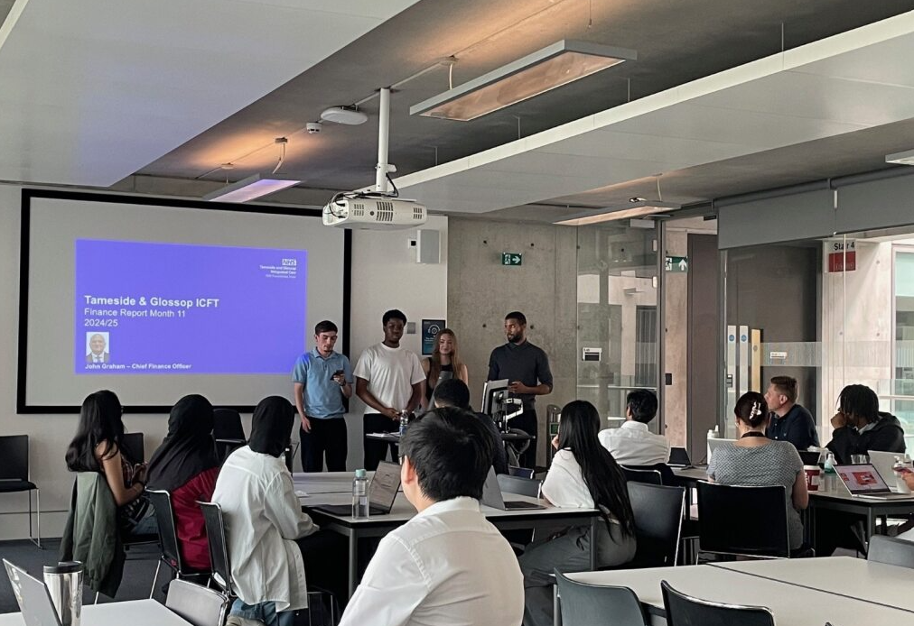

Following the team presentations, we hosted a dedicated Careers session in collaboration with university colleagues. The session began with the Placement Development Manager providing constructive feedback on each team's presentation, offering valuable suggestions and tips for improvement.

Next, the Placement Engagement Co-ordinator delivered a session focused on applying for internships and placements, including CV writing advice and guidance on interview preparation, along with information on the wider support available to students.

This was followed by a presentation from our NHS colleagues, who discussed career opportunities within the NHS, various entry routes, and the NHS Graduate Management Training Scheme. They also shared their own personal career journeys, aiming to inspire and motivate students to consider careers within the NHS.

The session concluded with the judging panel announcing the winning team and awarding trophies to the winners in recognition of their hard work and innovative ideas.

Finally, a lunch and networking session provided students with the opportunity to reflect informally on their experience, ask further questions about NHS careers, and speak with our current placement student about their own journey and experience on the placement

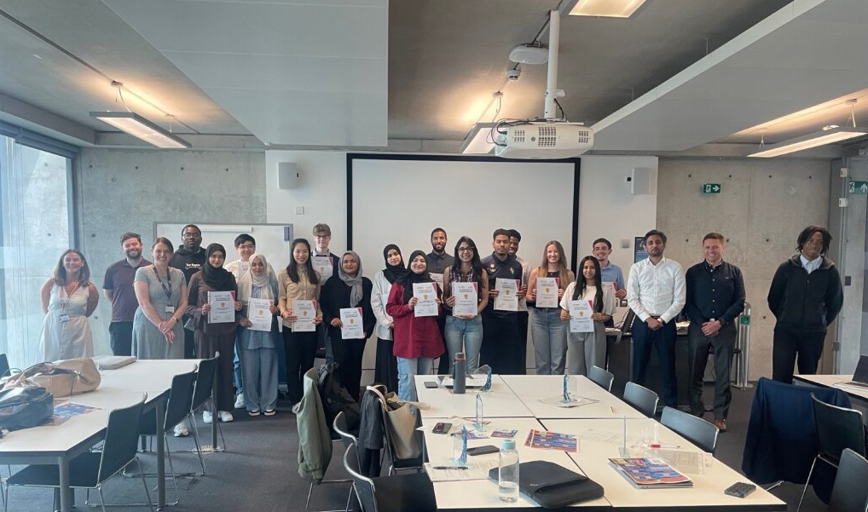

WORK EXPERIENCE OPPORTUNITY FOR THE WINNING TEAM
As a reward for their excellent performance, members of the winning team were invited to spend a day gaining work experience at the Trust. During their visit, they participated in both in-person and virtual meetings, providing them with a real-world insight into how our teams operate.

They also had a guided tour of the hospital site, led by a colleague from the Estates team, who showcased some of the major capital developments supported by the Finance and Procurement team, bringing to life the impact of financial decision-making within the Trust

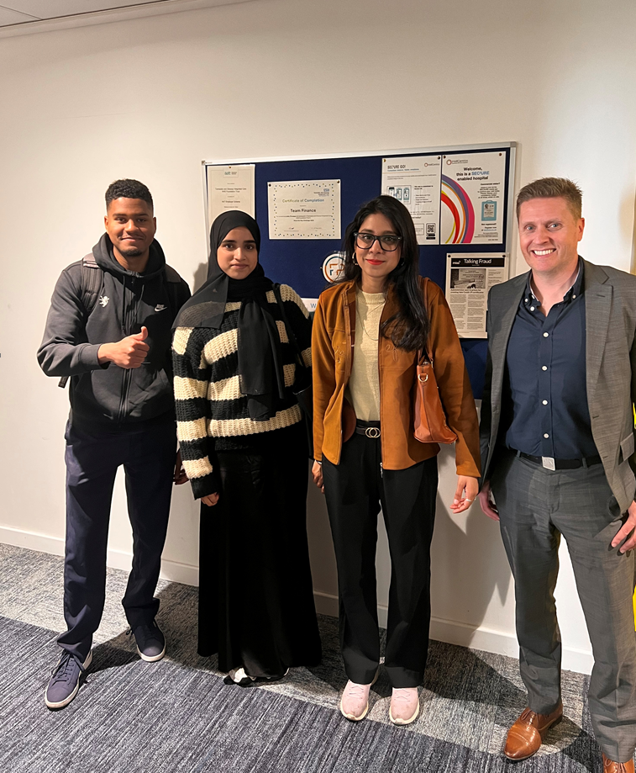

ENGAGEMENT AND FEEDBACK
We had very positive feedback from colleagues from MMU and the students themselves:

Charlie Hague, Placement Development Manager said “Working alongside Tameside and Glossop Trust on a live project was an incredibly rewarding experience for our students. The Trust’s openness to collaboration and their commitment to creating a meaningful learning environment made this partnership truly special.

Over the course of a week, 20 students engaged with a real-world challenge, applying their skills and creativity to develop innovative solutions. This project exemplified the power of reciprocal partnerships—where both students and employers’ benefit from shared knowledge, fresh perspectives, and mutual respect. It allowed students to enhance their CVs, engage in work-based learning, and explore potential roles in healthcare, all while contributing meaningfully to a real organisation.

We deeply value our relationship with Tameside and Glossop Trust and look forward to continuing this collaboration. We also welcome the opportunity to work with other NHS Trusts in a similar way, creating impactful experiences that prepare students for the future.”

Anna Hardy-Watmough, Faculty Employability Lead (Finance & Economics) said “This was an excellent opportunity for the students to gain experience of a real-world problem, working together to come up with innovative and relevant solutions. All teams provided solutions that the trust decided to take forward, with the winning team being offered a day of work shadowing as a reward. The project allowed students to bolster their CVs and engage in work-based learning, with the added advantage of learning more about possible roles in the NHS. We would love to continue this going forward and are open to working with other Trusts in a similar way.”

Student feedback from our survey showed:

- 100% of respondents felt the project week gave them the experience they were hoping for
- 100% of respondents would recommend other students to take part in similar projects
- When asked if they would have considered a career in the NHS before the project 17% said “no”, 33% said “maybe” and 50% said “yes” – after the project this changed to 67% said “yes” and 33% said “maybe”
- 67% are considering applying for the NHS Graduate scheme

We received many positive comments from students:

“The highlights of the summer project week were collaborating with people from diverse backgrounds, exchanging ideas, and watching those ideas grow through teamwork and creativity”

“I had an amazing time with my team and delivering my presentation effectively with the group I was put in was a highlight for me, and of course was the proud moment when our team won the trophies!”

“It was a valuable experience that allowed me to apply my academic knowledge, particularly in public sector finance, in a real-world context”

Reflections from our own staff at TGH:

We saw this project as a valuable opportunity to promote NHS Finance more broadly within the community, while also offering meaningful work experience to the next generation of potential talent. Initiatives like this provide students with real-world insight into the workplace and allow us to engage a wider audience—offering opportunities at a time when many organisations, particularly in times of financial pressure, may view placements as a luxury rather than a priority.

It was also an incredibly positive and rewarding experience for our own staff, who appreciated the chance to give back to the local community and contribute to developing future professionals

IMPACT AND OUTCOMES
From a student perspective, the key benefits included a greater awareness of career opportunities within the NHS, including the NHS Graduate Management Scheme, and an improved understanding of how finance operates within a healthcare setting.

Perhaps most significantly, the project helped students develop essential skills in teamwork and problem-solving—working collaboratively to deliver a defined outcome based on a specific brief. These experiences not only enhanced their practical understanding but also provided valuable material for future job applications and interviews, giving them a strong example to highlight on their CVs

From our organisation’s perspective the project provided valuable, external insights and practical recommendations for improving our Finance Board Report. It also offered a unique development opportunity for staff, allowing them to engage in mentoring and collaborative work outside of their usual roles. Most importantly, it gave us the chance to contribute positively to our local community—an experience that was both rewarding and meaningful for everyone involved.

CHALLENGES AND LESSONS LEARNED
If we were to run a similar project in the future, we would aim to involve a wider range of staff from TGH, particularly those in more junior roles. This would provide them with a valuable development opportunity—allowing them to engage in a different type of work, with a different audience, outside of their usual day-to-day responsibilities.

We did encounter a few technical issues at the beginning of the project week, such as firewall restrictions that made it difficult to share files externally. While we were able to find a workaround quickly, this highlighted the importance of testing IT systems and file-sharing processes in advance when working across organisations.

Another point of reflection was whether the five-day timeframe was sufficient for the complexity of the project. Given the volume of data involved — and the students' lack of prior exposure to NHS finance or large financial datasets — a two-week format may have allowed more time for understanding, analysis, and deeper engagement with the task.

FUTURE PLANS

Building on the overwhelmingly positive feedback from everyone involved, we are keen to run a similar project again in the future, potentially as early as next year. The benefits have been clear: valuable learning and development for the students, meaningful engagement and growth opportunities for our staff, and a strong sense of shared achievement across all participants.

This is a project we’re extremely proud of, and one we believe offers a sustainable and impactful way to support young people, particularly in today’s financially challenging environment, by opening up real opportunities for professional development and career exploration.

